Train 1-4 confusion:

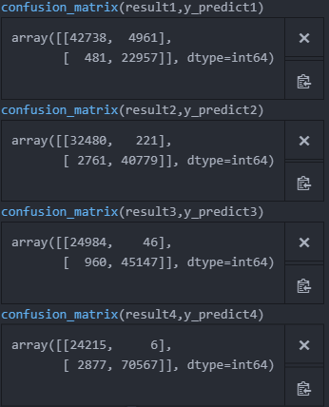

Test 1-2 confusion

